Insert School Logo

Semester One

Examination 2020

Question/Answer booklet

MATHEMATICS
SPECIALIST UNIT 1

Section One:
Calculator–free

Student Name: _____________________________________
Teacher’s Name: _____________________________________

Time allowed for this section
Reading time before commencing work: five minutes
Working time for paper: fifty minutes

Material required/recommended for this section

To be provided by the supervisor
This Question/Answer booklet
Formula Sheet

To be provided by the candidate
Standard items: pens (blue/black preferred), pencils (including coloured), sharpener, correction tape/fluid, erasers, ruler, highlighters
Special Items: nil

Important note to candidates
No other items may be taken into the examination room. It is your responsibility to ensure that you do not have any unauthorised notes or other items of a non–personal nature in the examination room. If you have any unauthorised material with you, hand it to the supervisor before reading any further.

Structure of this paper

 | Number of questions available | Number of questions to be attempted | Working time (minutes) | Marks available | Percentage of exam
Section One  Calculator—free | 6 | 6 | 50 | 50 | 35
Section Two  Calculator—assumed | 12 | 12 | 100 | 100 | 65
 |  |  |  | Total marks | 100

Instructions to candidates

- The rules for the conduct of Western Australian external examinations are detailed in the
Year 12 Information Handbook 2020. Sitting this examination implies that you agree to abide by these rules.

- Answer the questions according to the following instructions.

Show all your working clearly. Your working should be in sufficient detail to allow your
answers to be checked readily and for marks to be awarded for reasoning. Incorrect answers given without supporting reasoning cannot be allocated any marks. For any question or part question worth more than two marks, valid working or justification is required to receive full marks. If you repeat an answer to any question, ensure that you cancel the answer you do not wish to have marked.

It is recommended that you do not use pencil, except in diagrams.

- You must be careful to confine your responses to the specific questions asked and to follow any instructions that are specific to a particular question.

- Spare pages are included at the end of this booklet. They can be used for planning your responses and/or as additional space if required to continue an answer.
- Planning: If you use the spare pages for planning, indicate this clearly at the top of the page.
- Continuing an answer: If you need to use the space to continue an answer, indicate in the original answer space where the answer is continued, i.e. give the page number. Fill in the number of the question that you are continuing to answer at the top of the page.

- The Formula Sheet is not handed in with your Question/Answer Booklet.

Section One: Calculator–free 35% (50 marks)

This section has six (6) questions. Attempt all questions. Write your answers in the spaces provided.

Spare pages are included at the end of this booklet. They can be used for planning your responses and/or as additional space if required to continue an answer.

- Planning: If you use the spare pages for planning, indicate this clearly at the top of the page.
- Continuing an answer: If you need to use the space to continue an answer, indicate in the original answer space where the answer is continued, i.e. give the page number. Fill in the number of the question(s) that you are continuing to answer at the top of the page.

Working time: 50 minutes

Question 1 (5 marks)

(a) The diagram shows parallelogram OABC with M and N as the midpoints of line
segments $\overline{\text{OA}}$ and $\overline{\text{AB}}$ respectively.
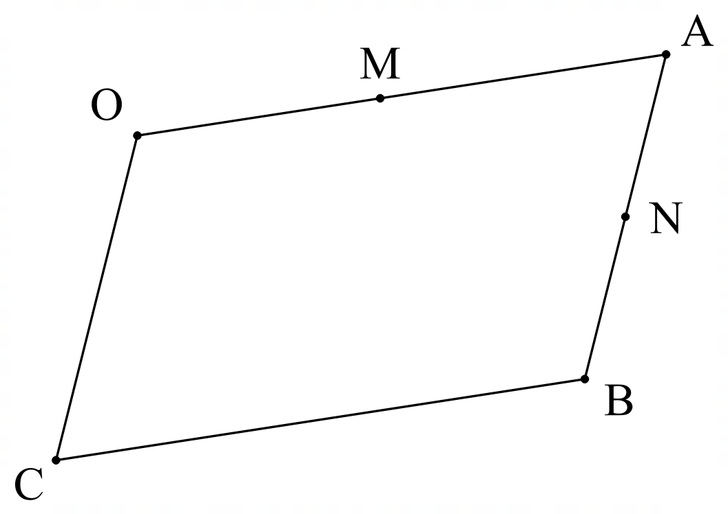
If $\vec{\text{OA}}\text{ = }\text{a}$ and $\vec{\text{AB}} \text{= }\text{b}$, then express each of the following in terms of a and b.
(2 marks)

(i) $\vec{\text{CO}}=$

(ii) $\vec{\text{MB}}=$

(b) In ΔPQR shown, X divides PQ in the ratio 2 : 5.
If $\vec{\text{QR} }\text{=} \text{a}$ and $\vec{\text{PR} }\text{=} \text{b}$, then determine $\vec{\text{RX }}$ in terms of a and b. (3 marks)
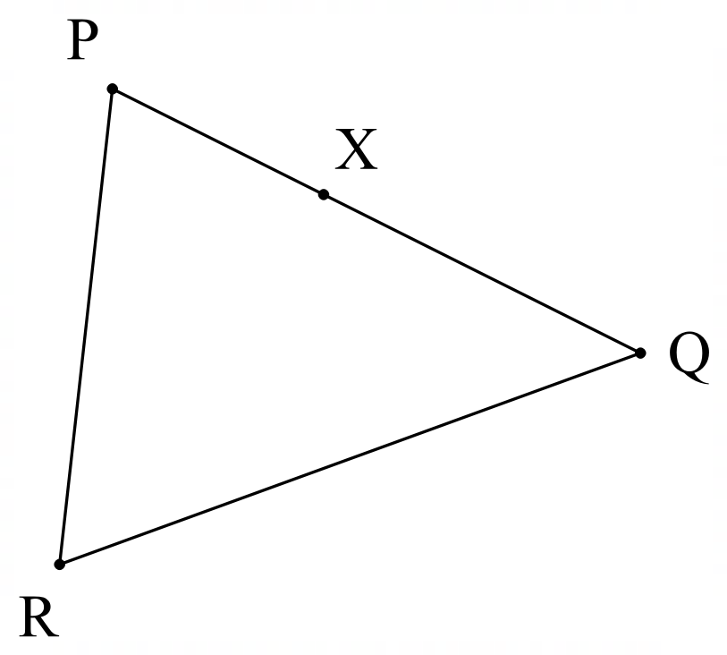

Question 2 (12 marks)

Consider the portion of Pascal’s triangle shown below.

 |  |  |  |  |  |  |  |  | 1 |  | 2 |  | 1
 |  |  |  |  |  |  |  | 1 |  | 3 |  | 3 |  | 1
 |  |  |  |  |  |  | 1 |  | 4 |  | 6 |  | 4 |  | 1
 |  |  |  |  | 1 |  |  | 5 |  | 10 |  | 10 |  | 5 |  | 1
 |  |  |  | 1 |  |  | 6 |  | 15 |  | 20 |  | 15 |  | 6 |  |  | 1
 |  | 1 |  |  | 7 |  |  | 21 |  | 35 |  | 35 |  | 21 |  | 7 |  |  | 1
 | 1 |  | 8 |  |  | 28 |  |  | 56 |  | 70 |  | 56 |  | 28 |  | 8 |  |  | 1

(a) Evaluate.

(i) 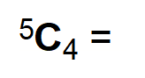 (1 mark)

(ii) 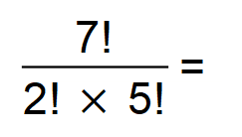 (1 mark)

(b) State the value of x in each case below.

(i) 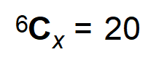 (1 mark)

(ii) 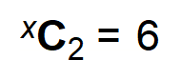 (1 mark)

(iii) 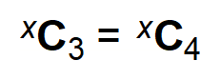 (1 mark)

(iv) 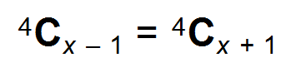 (1 mark)

Question 2 (Continued)

A basketball team requires 5 players.
A team is to be selected from 2 centres, 2 forwards and 3 guards.

(c) (i) How many different teams of 5 are possible if there are no restrictions?
(1 mark)

(ii) How many teams can be chosen if it must contain at least one centre?
(2 marks)

5 players are chosen as a starting team and line up at the start of a game.

(d) How many different arrangements are possible if:

(i) no restrictions apply? (1 mark)

(ii) the starting team has 2 guards, and they must stand next to each other? (2 marks)

Question 3 (10 marks)

(a) OC is a radius of a given circle, with centre O.
A and B are points on OC and OC extended, such that OA x OB = OC².
A circle passes through A and B, and intersects the given circle in X and Y.

(i) Complete the diagram by marking A, B and C on the diagram. (1 mark)

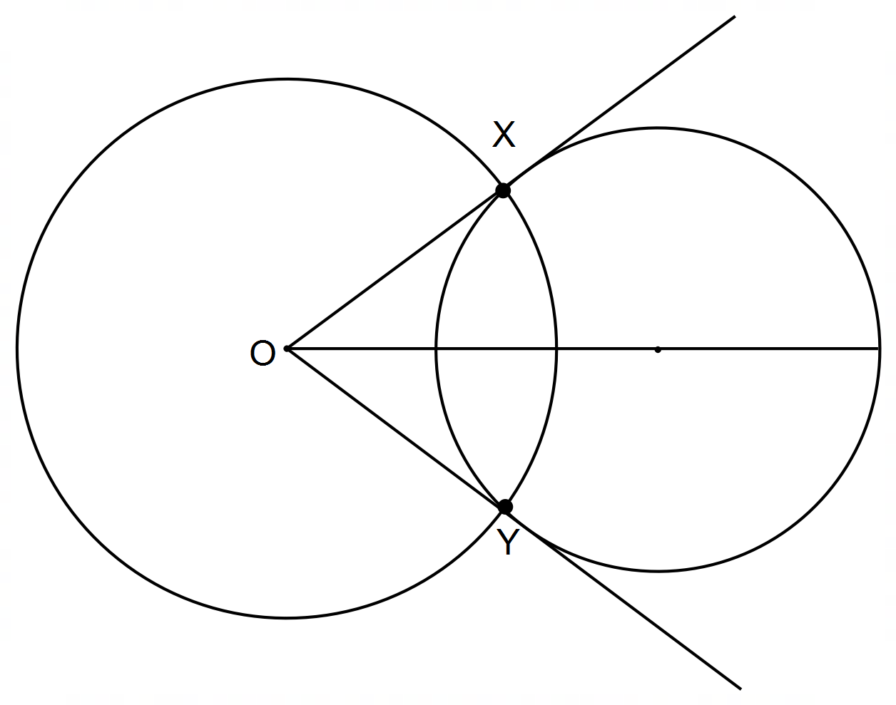

(ii) Prove that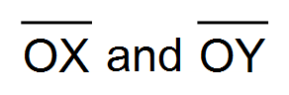are tangents to this circle. (4 marks)

Question 3 (Continued)

Food items are to be made into parcels.

(b) 16 food items are to be made into two parcels; one containing 10 items and the other 6 items.
In how many ways can the two parcels be formed?
Leave your answer in the form 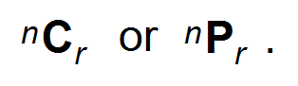 (2 marks)

(c) 16 food items are to be made into three parcels, containing 10, 4 and 2 items respectively.

(i) In how many ways can the three parcels be formed?
Leave your answer in the form  (2 marks)

(ii) Once the three parcels have been made, how many ways can they be
delivered to three needy families, one parcel to each family? (1 mark)

Question 4 (12 marks)

Three vectors are given by $\text{a} \text{=} \text{3}\text{i} -\text{6}\text{j}$, $\text{b} \text{=} -\text{3}\text{i} -\text{4}\text{j}$ and $\text{c} \text{=} \text{i} \text{+}\text{ 3}\text{j}$.

(a) Determine:

(i) a + b – c. (1 mark)

(ii) |b|. (1 mark)

(iii) 3b + 2c. (2 marks)

(iv) the unit vector $\hat{\text{d}}$ that is parallel and in the same direction as b − a. (3 marks)

Question 4 (continued)

(b) Determine the projection vector of c onto a. (4 marks)

(c) Draw a vector diagram containing the vectors m, n and p such that m – n + p = 0.
(1 mark)

Question 5 (6 marks)

Consider the diagram shown. O is the centre of the circle.

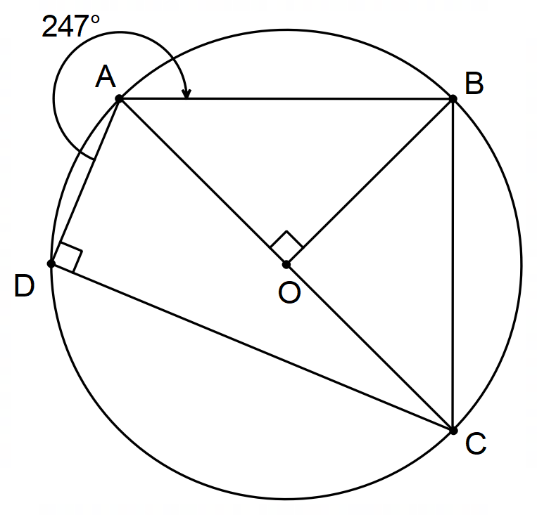

Determine the size of the following angles giving reasons for your answers:

(a) 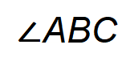 (2 marks)

(b) 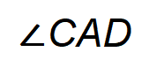 (2 marks)

(c) 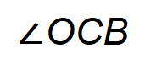 (2 marks)

Question 6 (5 marks)

Use proof by contradiction to show that there are no integers for which 8x – 24y = 5.

End of questions
Additional working space

Question number(s): ……………………

